

BILKENT UNIVERSITY SCHOOL OF ENGLISH LANGUAGE
MATERIALS DESCRIPTION FORM
LEVEL: PRE-INTERMEDIATE

THEME: | TITLE OF THE MATERIAL:  Q SKILLS-L & S IN CLASS VOCABULARY GAME:  UNIT 6 QUIZLET LIVE

SKILL:  VOCABULARY | OBJECTIVE:  - Students will work in groups to match the correct vocabulary word to the definition given.

PREPARED / adapted BY: Yeşim Yeloğlu

QUIZLET LIVE
Go to https://quizlet.com/ and sign up for a free account or log in to your existing account.
Click on this link: https://quizlet.com/tr/712313074/q-skills-1-ls-unit-6-flash-cards/
Click on LIVE
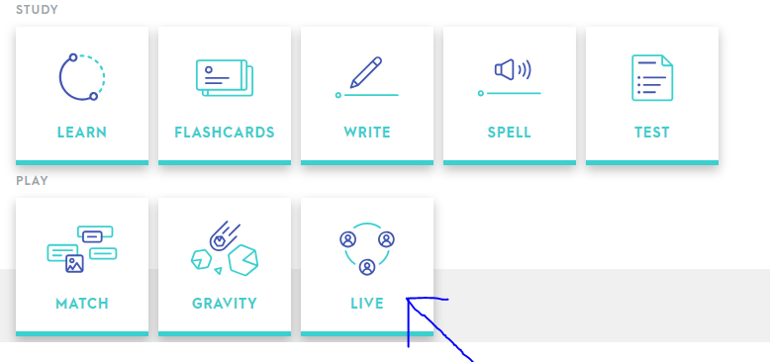
Then choose CREATE GAME
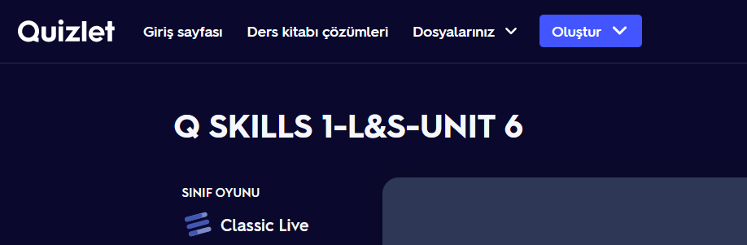
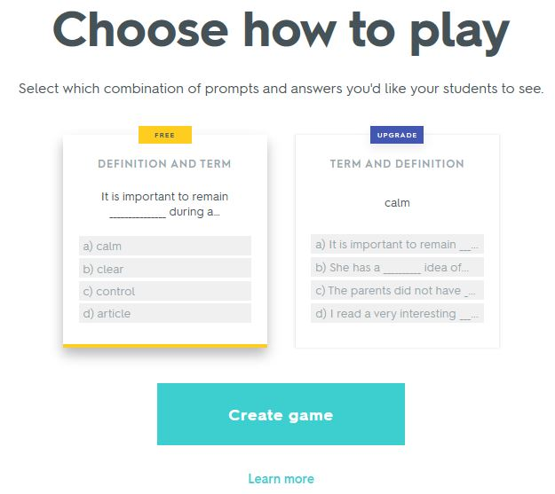
Under “Choose How to Play” choose Create Game again. The definition and term setting is
Students will be given a code to sign into the game
Once all students have signed in, click CREATE GAME WITH (X) STUDENTS

Students will be randomly assigned to groups. 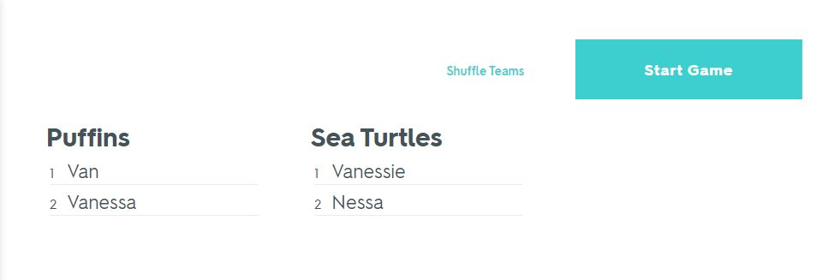
Instruct students to sit with their groups. This works best if students are facing one another rather than sitting next to each other as this facilitates more group interaction.
When a sentence or definition appears on their phones, only one student from the group will have the correct answer. Students should discuss the possible answer before selecting the correct answer. They should not show their phone screens to the other members of the group, instead they need to tell the other group members what words they have and talk about possible answers.
When they get a correct answer their group earns points. An incorrect answer will send them back to 0 so they need to discuss each answer and agree on what is correct before they answer.
At the end of the game, you have the option of reviewing the questions that students had trouble with as well as the ones they answered correctly. If students consistently get the right answer, they will only get 12 questions and will not get tested on the entire vocabulary list. So, once they have finished you can click play again and let them play a few rounds until the words start repeating.

